**Execution Procedure for running code through Command Prompt**

1. Kindly open the GitHub link in the email and click on the “Code” button highlighted below

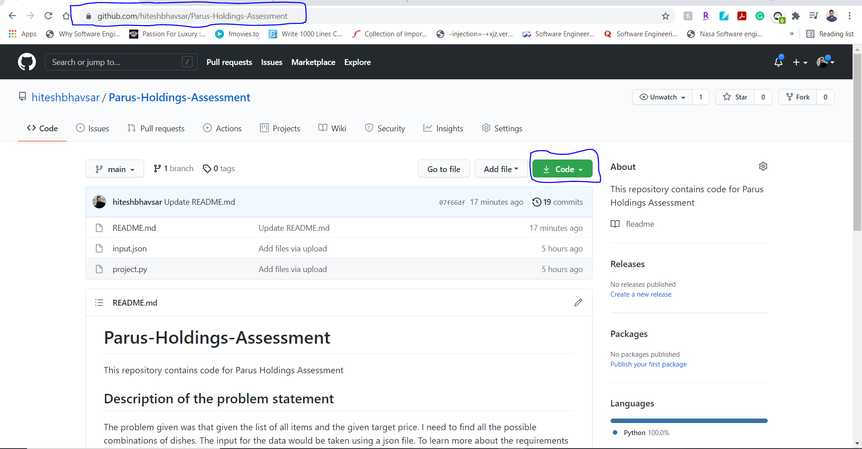

1. After clicking the code button select “Download Zip “

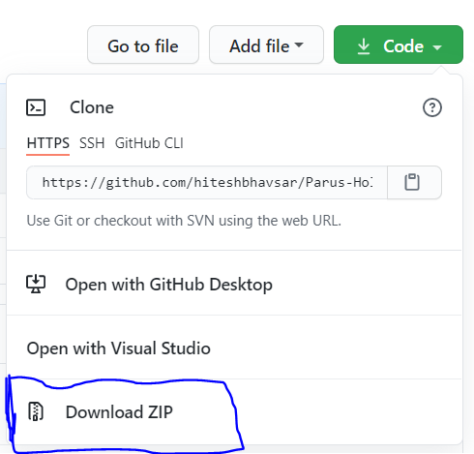

1. After downloading the zip file extract to a folder

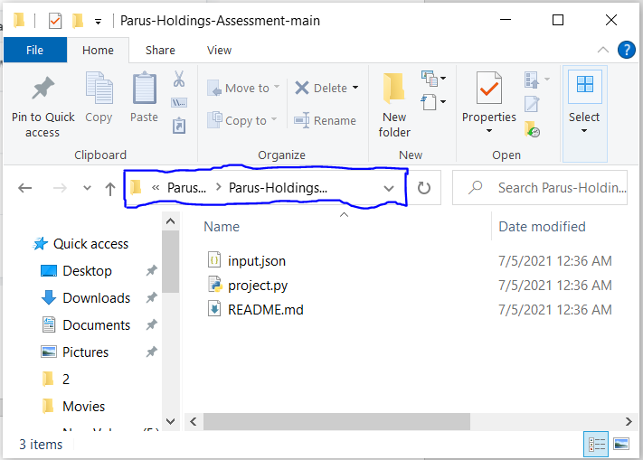

1. After opening the folder click on the folder path as shown above and click backspace and type cmd (Command Prompt)

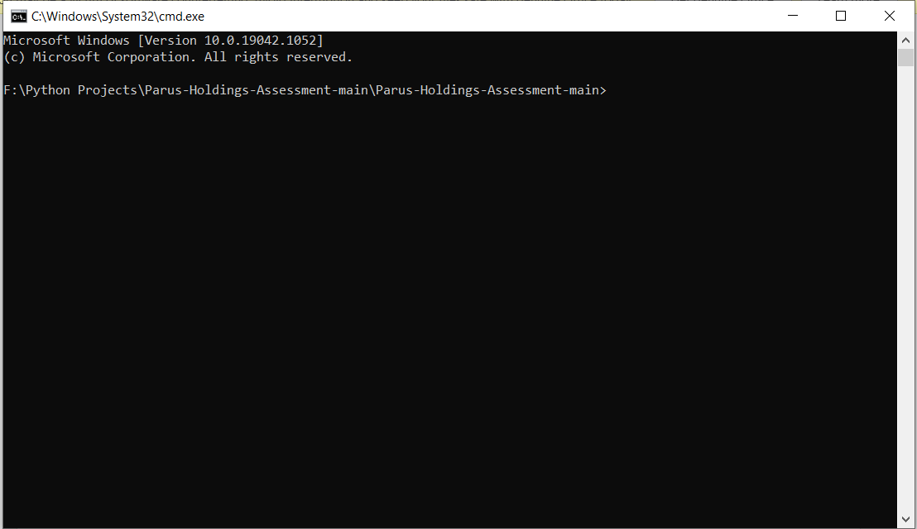

1. Type the command “python project.py input.json” and click enter. [Here you can choose to have different file names by replacing ‘input.json’ part with the file name (if in same directory) or file path (if in different directory)]
2. The output of the code will be displayed as given below

